# Department of Computing

# MATH 333: Numerical Analysis

# Class: BSCS-6AB

# Lab 5: Regular Falsi Method and Fixed Point Method

# Date: February 22, 2019

# Time: 10:00-12:50hrs- 14:00-16:50hrs

# Instructor: Atifa Kanwal

# Lab Engineer: Azaz Farooq

# Abdul Basit

# 193227

# BSCS-6B

**Lab Solution:**

# Lab 5: Regular Falsi Method and Fixed Point Method

**Introduction**

False position ( regula falsi ) method which is defined as a closed numerical method used for

find the roots of equations and polynomials.

**Objectives**

The purpose of this lab is to get familiar with Regular Falsi and fixed point method.

**Tools/Software Requirement**

Matlab R2016a

**Description**

First of all, we need to predict a value for the roots (lower and upper guess)

* xl (xlower); lower guess
* xu (xupper); upper guess

For these two values of function f we will find;

* For xl f(xl)
* For xu f(xu)

The following equation called as a false position formula:

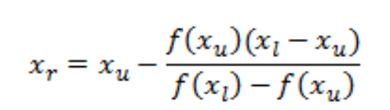

**Fixed Point Method**

This method determines a fixed point of an equivalent equation. The equation is rewritten in the form x = g(x).

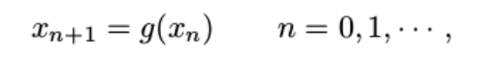

**Main Steps**

Declare equation.

* Declare main body of code and call function that performs iteration.
* Write function that performs iteration.

**Lab Task**

1. Implement Regular falsi method as function. Take function, initial guess, tolerance and

other required parameter as input from user. find its roots.

*f* (*x*) =x-2sinx^2

**CODE:**

function[str] = falsi(xl,xu,tol,f)

% xl is the lower guess

% xu is the upper guess

% tol is the tolerance for the error

% f is the function

%defining variable x

syms x;

%taking inputs for the input parameters

f(x) = input('Enter differentiable function:')

xl=input('Enter lower guess:')

xu=input('Enter upper guess:')

tol=input('Enter Tolerance:')

%Checking if the guesses are correct or not

if f(xu)*f(xl)<0

else

fprintf('Wrong Guess! Enter new guess \n');

xl = input('Enter lower guess:\n');

xu = input('Enter upper guess:\n');

end

%loop fot the function

for i = 2:1000

nl = (xu.*f(xl));

nu = (xl.*f(xu));

num = nl - nu;

dl = f(xl);

du = f(xu);

den = dl - du;

xr = num/den;

fprintf('%f',xr)

if f(xu)*f(xr)<0

xl = xr;

else

xu=xr;

end

if f(xl)*f(xr)<0

xu=xr;

else

xl=xr;

end

xnew(1) =0;

xnew(i)=xr;

if abs((xnew(i)-xnew(i-1))/xnew(i))<tol

break

end

end

%printing the value of root for the function

str = ['Root: ', num2str(double(xr)), ''];

**SCREENSHOT:**

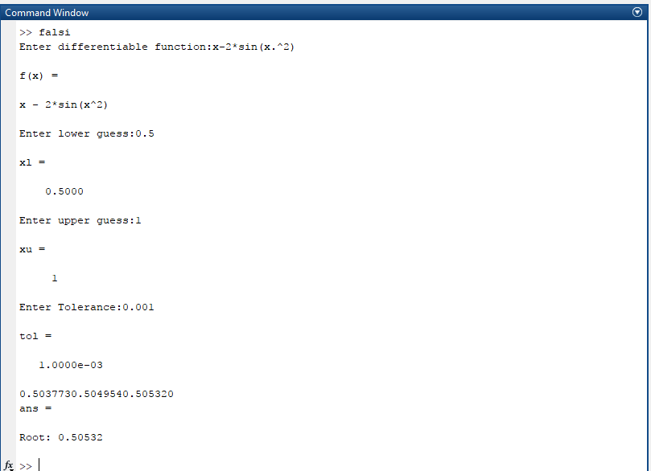

1. Implement fixed point method as function. Take function, initial guess, tolerance and

other required parameter as input from user. find its roots.

*f* (*x*) = x-2sinx^2

**CODE:**

%giving the equation to the compiler

g=@(x) x-2*sin(x^2);

%setting the iterations level

x1 = 2;

%setting iterations for the function

x2 = g(x1);

iterations = 0;

%while loop for the false position method

while (abs(x2-x1) > 1e-5 && iterations<50)

iterations = iterations + 1;

x1 = x2;

x2 = g(x1);

end

iterations

%printing the values

[x1 x2]

**SCREENSHOT:**

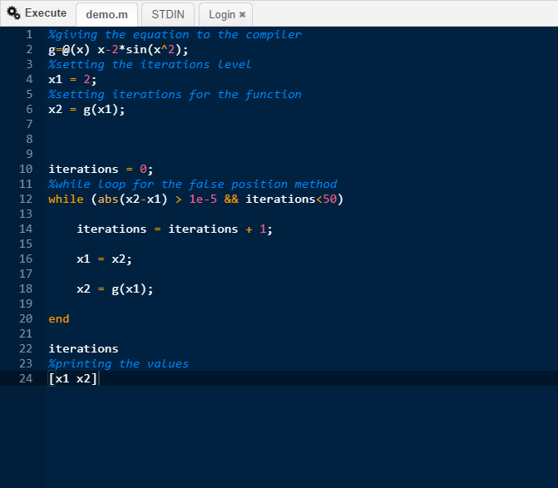

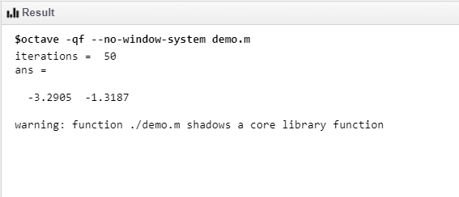

**Deliverables**

Submit single word file with matlab code and screen shot of Output.